**The Potato Eaters**

**Vincent Van Gogh**

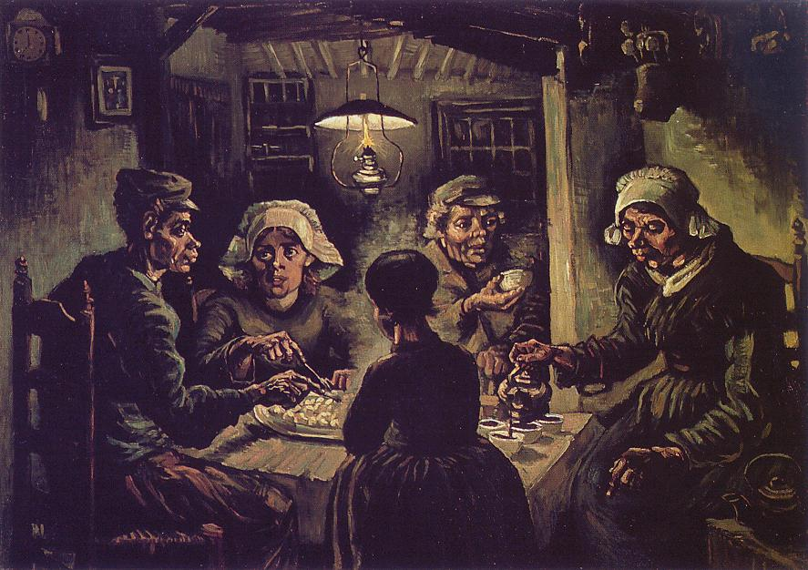

**Painting references:**

* <https://designercityline.wordpress.com/2010/03/15/writing-analysis-of-the-potato-eaters-by-van-gogh/>

**Sorry**

I’m sorry, said the tired farmer to his little daughter

Sorry, because we can’t have what They have.

They, the ones who wine and dine,

While the kinds of you and me starve.

Why do we eat only potatoes every night Daddy, you ask

I’m sorry, because I do not have the courage to tell you why.

Why can we only light our little lamp for an hour each night, you ask

I’m sorry, because I’m not strong enough

To tell you your father can’t even afford to buy you light.

Why are your hands so rough Daddy, you ask

I’m sorry, because it pains me to know

Your delicate little hands will one day look like mine.

Why does Grandma look so pale now, Father

Why does she always give me her potatoes?

I’m sorry, but I don’t know if you’ll understand

When I tell you she’s slowly preparing to meet the Angels.

Sorry, because of all the questions you ask, that I cannot answer.

Sorry, because we had no silver spoons to give you, when you were born.

Sorry, because I cannot make you stronger to face the world out there,

Because for that, I would have to crush your little big heart.

My sweet child,

I’m *sorry*.

Soumi Chakraborty

ES19BTECH11017